

*Buffalo River*

*Final Project*

*(PE 4590 Spring 2017)*

By: Simon Njoku, Cody Boynton, Shivani Patel

Group 9



MAY 9, 2016

MISSOURI UNIVERSITY OF SCIENCE & TECHNOLOGY

gggg

**Table of Contents**

Executive Summary…………………………………………………………………………….…1

Introduction……………………………………………………………………………….……….1

Geology………………………………………………………………………………………………...1

Reservoir Rock and Fluid Properties………………………………………………………....1

Procedure………………………………………………………………………………………….1

Results………………………………………………………………………………………….….1

Table 1: Net present value for the individual compressors with respect to the percentage increase….2

Table 2: EMV for the different compressors…………………………………………………….……2

Discussion…………………………………………………………………………………………3

Conclusion……………………………………………………………………………………...…3

.

References…………………………………………………………………………………………3

Appendices………………………………………………………………………………………...4

Figure 1: Overall view of the decision tree displaying the NPV and EMV for each scenario………..4

Figure 2: 3 Compressors, ideal scenario. Each other scenarios follow this layout, to simplify, only one will be shown…………………………………………………………………………………………..4

**Executive Summary**

The Buffalo River Unit Project is one of three High-Pressure Air Injection (HPAI) projects in the Buffalo Field currently operated by Continental Resources. It produces from the Red River reservoirs which are deep (~8,400 ft), thin (~15 ft), hot (215 °F), low permeability (~10 md) carbonates. The unit comprises 4,560 acres with 15 producing wells, was formed in July of 1987 and began air injection operations four months later.

Before unitization, the oil production was declining steadily but the response to air injection has resulted in a significant production increase over its historical decline. While Buffalo River unit production in July 1987 was 200 BOPD, a peak production rate of 500 BOPD was achieved in January 1990, with 15 producing wells after the injection of 2 BSCF of air. As of December 2006, about 23 BSCF of air had been injected, for a cumulative oil production of 2.3 MMSTB since the beginning of injection.

**Introduction**

Currently, Continental Resources operates the field under high pressure air injection through multiple injection wells that help push flow into the producing wells. To do this, five operational compressors are in place to compress atmospheric air to adequate pressure for air flooding the reservoir. The Buffalo River Unit currently operates with four compressors idle due primarily to well-decline and a drop-in oil prices.

While running one compressor is economically feasible, an investigation is to be run, to grasp an understanding on the economic benefit to running multiple compressors at a time. This process incorporates the use of two software applications, Pyxis OGRE R3 and Silver Decision. Both software is used to obtain a net present value (NPV) and create a decision tree for an expected monetary value (EMV) understanding, respectively. If successful, an economically attainable value is obtained after running the various scenarios, a decision will be made on how many compressors is optimal for the given reservoir during the economic downturn.

**Geology**

The River Basin Formation is present throughout the basin and hydrocarbon reservoirs occur in both structural and stratigraphic traps; oil entrapment occurs by complex combinations of up-dip porosity pinch-out, reduction in pore-throat diameter, low relief structural closures and low displacement faulting. It is composed primarily of limestone and dolomite and is divided into upper and lower units.

**Reservoir Rock and Fluid Properties**

The porosity and permeability cut-offs were based on the core analyses including capillary pressure data and represent the minimum pay thickness that should contribute to the oil recovery. The reservoir drive mechanism is liquid expansion and rock compaction, which augmented by the low thickness and low permeability of the reservoir makes primary production an inefficient process.

**Procedure**

1. Read through the project handout and gain an understanding of what needs to be completed, ask supervisor (class instructor) for parameters.
2. Configure a decision tree using Silver Decision software to assess the probabilities of all possible scenarios with the given data on the project handout. Given probability data by simulation, there is 50% likelihood that a second compressor will increase flow rates by around 6% and 50% likelihood that a second compressor will increase flow rates by around 10%. In addition to that, each subsequent compressor would have 30% less of an effect without any effect on decline characteristics.
3. Apply reservoir and economic parameters into Pyxis OGRE R3 software to establish NPV for each given scenario. These parameters include 15% Royalty, 12% absolute rate of return, yearly production data for oil and gas along with their respective price, operating costs of $200M per compressor, reservoir decline, incremental and severance tax of 34% and 4.5%, respectively.
4. Also, consider given decline characteristics of field operating at exponential decline with a transition to harmonic decline soon. Another factor to be considered is current oil prices with current operations. Current oil and gas price given is $55/bbl and $3.23/MCF respectively. There will be two price scenarios for oil and gas, leveled or growing. Furthermore, the probabilities that will relate to each scenario are as follows. Consider a 40% chance of level price scenario and 60% chance of growing price scenario, with a 4%/yr for oil and 3%/yr for gas increase.
5. Input NPV from Pyxis into decision tree software and EMV is calculated based on given probabilities. NPV and EMV is generally computed with the help of following equations:
$NPV= {PV}_{Benefits }- {PV}_{Costs}$

$EMV=\sum{(NPV*probability value)}$

6. Make recommendation and make an effective conclusion based on results and analysis.

**Results**

With all the data provided, Decision Tree and Pyxis software generated acceptable results. Pyxis Software used decline characteristics, production rate, tax and royalty, among others, to generate NPV for each compressor scenario. Decision Tree then took the generated NPV from Pyxis software and calculated EMV for each scenario branch, based on the given probabilities. An overall decision tree with all 5 compressors and each scenario of growing (high) or leveled (low) prices for oil and gas was created (Figure1). NPV for each compressor scenarios for leveled/growing and total EMV, can be found below in Tables 1 and 2.

**Table 1. - Net present value for the individual compressors with respect to the percentage increase**

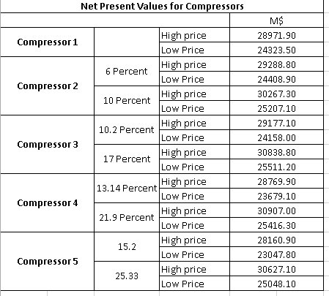

**Table 2. - EMV for the different compressors**

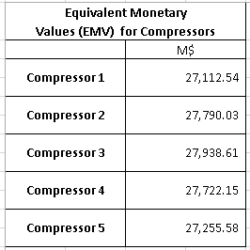

**Discussion**

The simulation yielded accurate potential EMV’s for each scenario, with the highest monetary value obtained using three compressors. however, we decided to evaluate all scenarios before concluding. A single compressor scenario was not chosen because that's the current situation used by company and our goal is to increase profit for company with not only maintaining current production but also keeping in mind the possibility of option to increase production in future. While it’s good to have an understanding for the given single compressor scenario EMV as a base case, ultimately, we would like to optimize economic recovery and an increase in number of compressors provided to be more economic.

Furthermore, Table 1 and 2 refers to NPV and EMV respectively of all different scenarios providing company an idea of overall cost or investment rate for compressors.

Running two compressors for air injection provides an increase in recovery and overall EMV when compared to the base case, yet falls short when paired next to three compressors. The extra $200M dollars spent on running a third compressor will only yield a $150M increase, however the incremental change in production outweighs the price difference. As for the four and five compressor scenarios, EMV starts to decline quickly and this is due in part to the operating cost for each compressor. With the price set at $200M dollars for each, the oil market must increase in $/bbl and $/MCF to make these scenarios economic.

**Conclusion**

The project mainly used Decision Tree and Pyxis software to configure different possible scenarios to conclude and recommend best scenario company can select to make profitable revenue from production. The company has options from using 1 to 5 compressors with operating cost of $200M per compressor. Based on economic analysis done using SilverDecisions and Pyxis, the best scenario for company to increase production and gain profitable and reasonable amount of revenue would come through use of 2 or 4 compressors.

However, after the investigative process, has occurred, the best decision moving forward with the Buffalo River field is to run three compressors for the high-pressure air injection, to increase the ultimate recovery and reach our most economic potential of $27, 938M for EMV (Figure 2).

**References**

* Course PowerPoint slides
* Petroleum Economics and Project Evaluation (Course book)
* SPE-107715-MS: Case History and Appraisal of the West Buffalo Red River Unit High-Pressure Air Injection Project
* Pyxis Reference Manual

**Appendices**

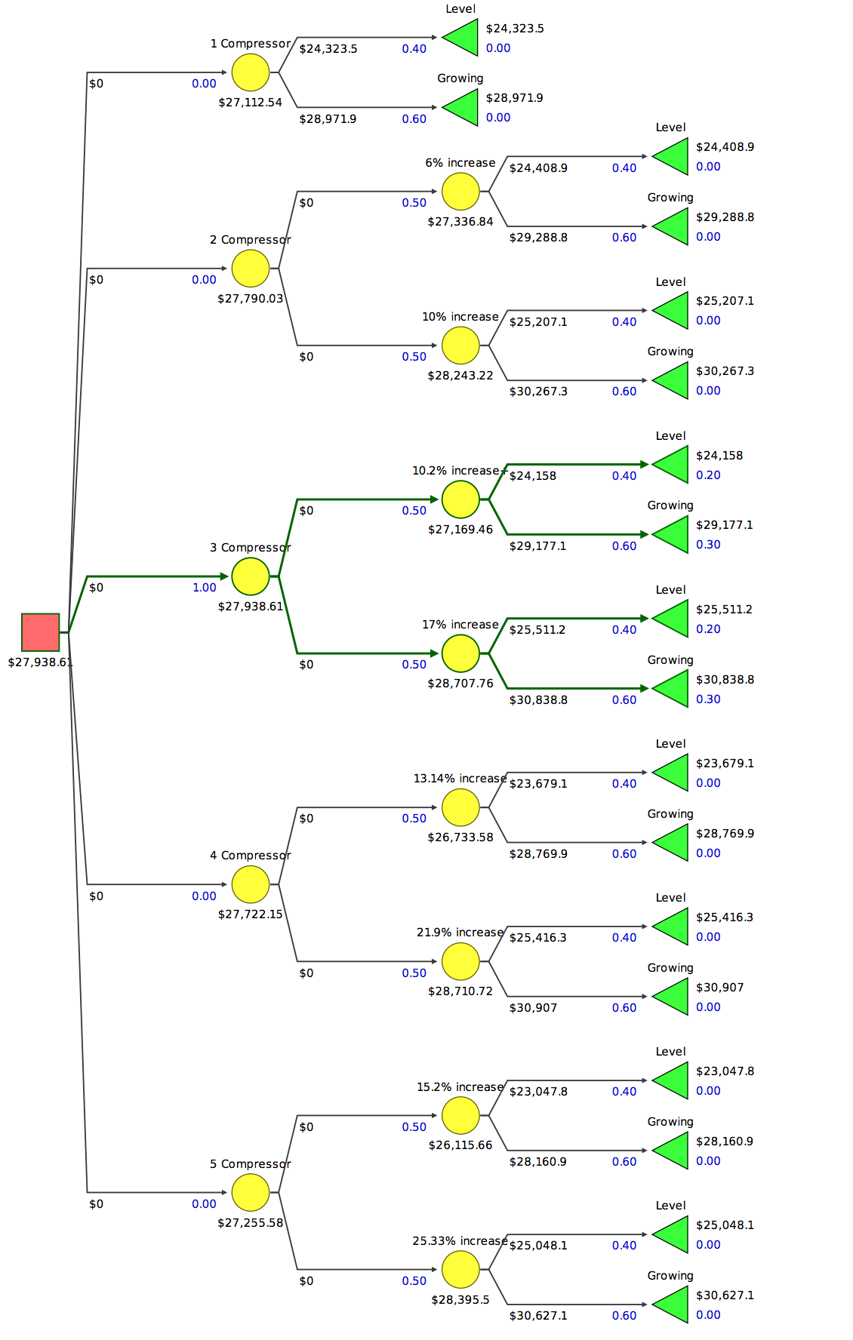

**Figure 1. - Overall view of the decision tree displaying the NPV and EMV for each scenario**

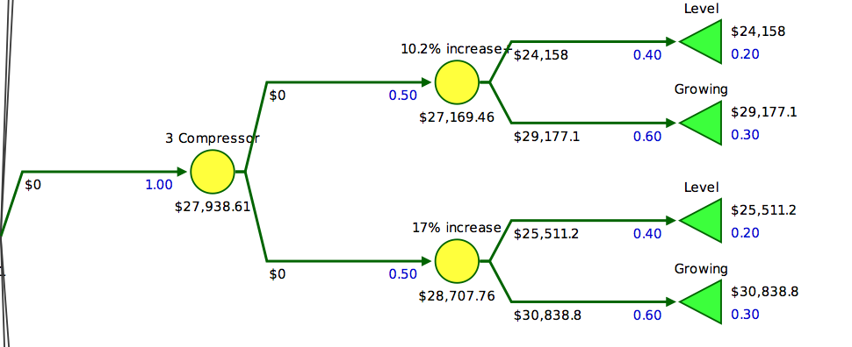

**Figure 2. - 3 Compressors, ideal scenario. Each other scenarios follow this layout, to simplify, only one will be shown.**

**Letter of Contributions**

Group participation has been shared equally, with all group members working diligently together as a team. Each person took a lead role in creating the necessary components of this project, along with the help of the remaining members. Simon commanded the Pyxis software with the help from Cody and Shivani. The Silver Decision tree was created by Cody with the help of each, Simon and Shivani. The overall report received equal parts of attention from the group members, with Shivani primarily delegating what to write.